

Texas CorCare®

Employee Notice of Network Requirements

English Version
CLM602/25/2015

About the network
Texas CorCare® is certified by the state of Texas as a Texas workers’ compensation health care network. Contact the network for assistance, a list of network providers, or to change treating doctors at:
CorVel Corporation
15301 Dallas Parkway, Suite 300 Addison TX 75001
Toll Free Number: 866-353-9768 E-mail: Texas_corcare@corvel.com

You must choose a “Treating Doctor”. Treating Doctors are able to provide treatment and refer to other specialists if needed.
Treating Doctors are the default selection on the website. To find a Treating Doctor or specialists on our website do the following:
- Go to http://www.corvel.com
- Select PPO Lookup
- Under Find A Provider, click Search
- Click the drop down menu for Select a Network
- Select the Texas CorCare Certified Network
- Enter the zip code where you live
- Keep “All” Selected for Specialty – Do not change the specialty for initial treatment
- Click Find Providers
Appointments will be given not later than 21 days after the request to see a provider. The network providers have agreed to look for payment only to the insurance carrier for compensable injuries.

Except in an emergency, you must have all care within the network through your treating doctor. If your doctor wishes to refer you outside of the network, the network must approve this. If you use a provider who is not in the network for non-emergency care without the network’s approval, you may have to pay for the services, not the carrier.

In an emergency, you may call 911 or go to the nearest hospital or emergency facility. This includes emergency care outside of the service area and after-hours emergency care.

Continuity of Care, if you have an acute life threatening condition and your treating doctor chooses to leave the network, the carrier must continue to pay the treating doctor for up to 90 days at the contracted rate.

If you are dissatisfied with any aspect of the network's operations or the network providers, your complaint must be filed with the network. The network must receive the complaint within 90 days of the event. No resolution is required if the complaint is not filed on time. The complaint must be sent to CorVel Corporation, Attention: Texas CorCare® Complaints at the address or email above. The network is not allowed to retaliate against you or your employer because of a complaint. The network is not allowed to retaliate against a provider, when representing your care, if the provider reasonably files a complaint against the network or appeals a decision of the network. Also, you may complain to the Texas Department of Insurance. Their website is www.tdi.state.tx.us. The address is HMO Division, Texas Department of Insurance, Mail Code 103-6A, P. O. Box 149104, Austin, TX 78714-9104.

NOTIFICATION OF NETWORK REQUIREMENTs
Your employer or insurance carrier will provide you with the network requirements at the start of the network. You should also receive this within 3 days of hire. Your employer should also give you the network requirements if you have a work related injury. They will give you an acknowledgment form. Please read the form carefully and sign it. Even if you refuse to sign it, Texas law requires you to follow the network rules.

Injuries prior to the network
Certain rules apply when you were injured before your employer chose to use this network. This applies to dates of injury before September 1, 2005 and after the date your employer first decided to use a network. You must live within the service area for these rules to apply. You must select a treating doctor when the carrier notifies you that health care is being provided through this network. You have 14 days to select a network treating doctor. If you do not select a network treating doctor the network may assign a doctor to you.

services needing preauthorization
- Inpatient hospital admissions and all surgeries and invasive procedures done in a facility other than a doctor’s office
- Length of stay, including length of stay starting the first working day after an emergency admission
- Repeat psychological evaluations, all testing, psychotherapy and biofeedback except when a part of a preauthorized rehabilitation program
- Osteopathic manipulation, chiropractic manipulations, physical therapy and occupational therapy except for the first 6 sessions within 2 weeks of the date of injury or an approved surgery
- All gym/health club memberships
- All myelograms, discograms, or surface electromyograms
- All repeat EMG/NCVs and all repeat diagnostic tests billed at $350 or greater
- All work hardening and work conditioning programs
- Pain management programs, chemical dependency or weight loss program
- All durable medical equipment (DME) billed at $500 or greater per item and all TENS units
- Nursing home, convalescent, residential care, and all home health practitioner services and treatments, including IV medications
- Any investigational or experimental services or devices
- Deviation from the guidelines adopted by the network
- Health care to treat an injury or diagnosis that is disputed by the carrier based on Labor Code §408.0042 after the Medical Examination By The Treating Doctor to Define Compensability

An adverse determination is a decision that a service is not medical necessary, is experimental or investigational. If you want to file an appeal, you must contact the company that did the denial within 30 days of the denial. If your life is in danger, you can ask for a review by an independent review organization right away.

Map of Texas CorCare®’s Service Area
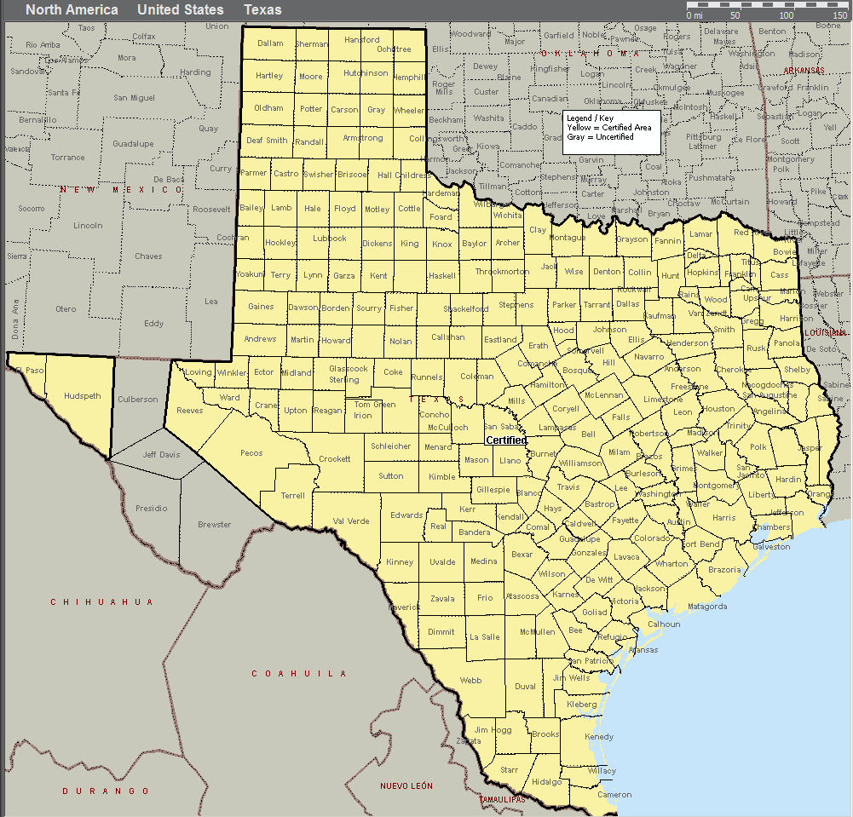

Disputing that you live in the service area
Contact the insurance carrier if you dispute that you live in the service area and include evidence to support your position. During the review of your dispute, you may seek all medical care from the network. If it is finally decided that you live in the network service area, the carrier may not have to pay for health care received out of the network. You may have to pay for that. If you disagree with the carrier’s decision you may file a complaint with the Texas Department of Insurance.

List of Counties in Network
Anderson* | Childress | Fayette | Hood | Lipscomb | Parker* | Taylor*
Andrews | Clay | Fisher | Hopkins | Live Oak | Parmer | Terrell
Angelina* | Cochran | Floyd | Houston | Llano | Pecos | Terry
Aransas | Coke | Foard | Howard | Loving | Polk | Throckmorton
Archer | Coleman | Fort Bend* | Hudspeth | Lubbock* | Potter* | Titus
Armstrong | Collin* | Franklin | Hunt* | Lynn | Rains | Tom Green*
Atascosa | Collingsworth | Freestone | Hutchinson | Madison | Randall* | Travis*
Austin | Colorado | Frio | Irion | Marion | Real | Trinity
Bailey | Comal* | Gaines | Jack | Martin | Red River | Tyler
Bandera | Comanche | Galveston* | Jackson | Mason | Reeves | Upshur
Bastrop* | Concho | Garza | Jasper | Matagorda | Refugio | Upton
Baylor | Cooke | Gillespie | Jefferson* | Maverick | Regan | Uvalde
Bee | Coryell* | Glasscock | Jim Hogg | McCulloch | Roberts | Val Verde
Bell* | Cottle | Goliad | Jim Wells | McLennan* | Robertson | Van Zandt
Bexar* | Crane | Gonzales | Johnson* | McMullen | Rockwall | Victoria*
Blanco | Crockett | Gray | Jones | Medina | Runnels | Walker*
Borden | Crosby | Grayson* | Karnes | Menard | Rusk | Waller
Bosque | Dallam | Gregg* | Kaufman* | Midland* | Sabine | Ward
Bowie* | Dallas* | Grimes | Kendall | Milam | San Augustine | Washington
Brazoria* | Dawson | Guadalupe* | Kenedy | Mills | San Jacinto | Webb*
Brazos* | Deaf Smith | Hale | Kent | Mitchell | San Patricio* | Wharton
Briscoe | Delta | Hall | Kerr | Montague | San Saba | Wheeler
Brooks | Denton* | Hamilton | Kimble | Montgomery* | Schleicher | Wichita*
Brown | DeWitt | Hansford | King | Moore | Scurry | Wilbarger
Burleson | Dickens | Hardeman | Kinney | Morris | Shackelford | Willacy
Burnet | Dimmit | Hardin | Kleberg | Motley | Shelby | Williamson*
Caldwell | Donley | Harris* | Knox | Nacogdoches* | Sherman | Wilson
Calhoun | Duval | Harrison* | La Salle | Navarro | Smith* | Winkler
Callahan | Eastland | Hartley | Lamar | Newton | Somervell | Wise
Cameron* | Ector* | Haskell | Lamb | Nolan | Starr* | Wood
Camp | Edwards | Hays* | Lampasas | Nueces* | Stephens | Yoakum
Carson | El Paso* | Hemphill | Lavaca | Ochiltree | Sterling | Young
Cass | Ellis* | Henderson* | Lee | Oldham | Stonewall | Zapata
Castro | Erath | Hidalgo* | Leon | Orange* | Sutton | Zavala
Chambers | Falls | Hill | Liberty* | Palo Pinto | Swisher
Cherokee | Fannin | Hockley | Limestone | Panola | Tarrant*
* indicates urban counties with a population > 50,000

Employee Acknowledgement Form

Effective: _________________________________
Check One: Initial Employee Notice
Injury Notice -- Date of Injury____________________

I have the information that tells me how to get health care under workers compensation insurance. If I am hurt on the job and I live in the service area described in this information, I know that:

- I must choose a treating doctor from the list of doctors who contracted with CorCare® or I may ask my HMO primary care physician to agree to serve as my treating doctor. If I select my HMO primary care physician to agree to be my treating doctor, I will call CorVel at (866) 353-9768 to notify them of my choice.

- I realize that, except for emergencies, I must get all health care, including referrals to specialists, from my CorCare treating doctor for my compensable work injury. If I need emergency care, I may go anywhere.

- The insurance carrier will pay the treating doctor and other network providers and will not bill me for a compensable injury.

- Except for emergencies, if I get health care that is not approved by CorCare®, from a doctor who is not with CorCare®, the insurance carrier may not pay for that care. I may have to pay for that care.

________________________________________________________
Employee's Signature Date

________________________________________________________
Employee's Printed Name

________________________________________________________
Employee's Address (Where I live)

________________________________________________________
City State Zip

________________________________________________________
Employers Name

CorVel Corporation/Texas CorCare®______________________________
Network's Name -- Return form to employer, carrier or third party administrator.

Texas Administrative Code, §10.101

